**Project Title:** FoodieVenture

**Brief overview of project purpose**

The FoodieVenture app aims to recommend users new foods dependent on their mood and dietary preferences. FoodieVenture provides users with a curated list of dining options that serve the recommended foods to help them discover new or pre existing local businesses they may have missed. It serves as a platform to motivate the community in exploring new cultures and unique global flavors, with 24/7 room for expression of how one feels, what flavors one craves, and experience creating the ideal taste in the comfort of one’s home. The food search functionality that the app supports is specially tailored for eaters bored with food in their daily routine, natural food explorers, picky eaters who only enjoy a limited menu, and those with dietary restrictions seeking a broader menu.

**Testing methodology and data collection**

For our test method, each team member individually conducted a usability test with a participant, following the script we had put together for [lab 5](https://docs.google.com/document/d/1p-DIASDNhiondf7gknsPivah-ay4_xxanmmhsEPvNRU/edit?usp=sharing). We selected participants randomly for our first test due to the limited availability of potential users. We collected data through observational notes based on participants’ performance with a task, their response to questions asked, and minor assists during the tests. We assisted participants only if necessary. Our team aimed to give as little information as possible.

**Results and feedback**

1. **☆ Foodie A. ☆**
   * **Was it an informal interview while they used the prototype, or did you give users tasks to do?**

Using our lab 5 test script I gave the user tasks to do. This was a more formal interview.

* + **How did you collect data from the interview?**

I collected the data by following the lab 5 test script, and made observations from this in person interview that I conducted.

* + - **Observe how long it takes for participants to create an account**
      * 10 seconds
    - **Record number of errors and time it takes for participants to find wishlist**
      * Kind of hard for her to find the wishlist, she wished there was a heart or star next to the dishes in the history.
      * There’s nothing that says she could favorite or add the dish to the wishlist from the history section.
      * However the location of the wishlist button on the profile section made sense to her.
      * It took her 30 seconds to find it.
    - **Observe whether participants understood how to save foods and businesses to their wishlist**

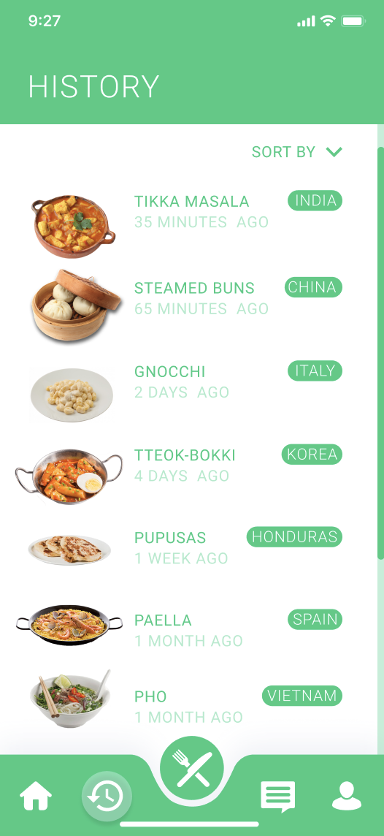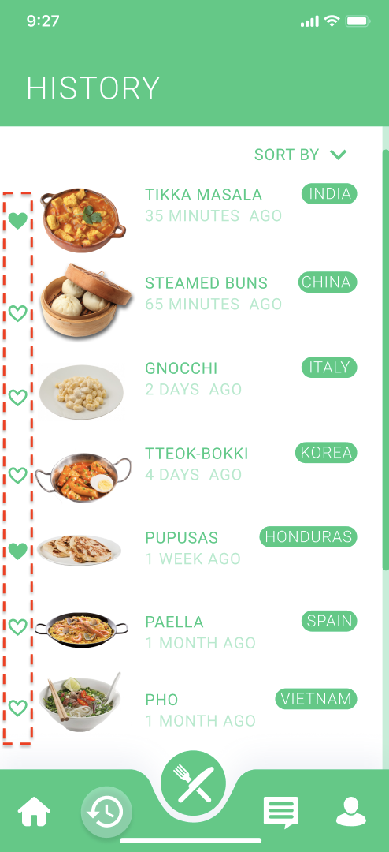

**Figure 1.1 Figure 1.2**

* + - * We need to add a “save to wishlist” heart button for the dishes in the history section, as pictured in **Figure 1.2**. **Figure 1.1** is the current prototype for this page. Having this button added to the Food Generator results page is another thing we need to do.
    - **Observe participants’ response to Food Generator results**
      * She loved the results, because she’s Indian and the dish that was generated happened to be Indian.
      * She also liked how informative the results were about the dish.
    - **Observe whether participants recognized what each tab and icon meant or represented**
      * She kind of, just explored around, and clicked around.
      * She accomplished all the tasks.
    - **What surprised you about the app?**
      * “I liked how the descriptions of the dishes were very in depth and I liked that I could make it at home or go out to eat.”
    - **What did you like about the app?**
      * “It was simple to use, even when there was a lot of information it didn’t feel overwhelming.”
    - **What did you dislike about the app?**
      * “More explanation on the newsfeed, do I use it as social media, or is it like friends that have the app nearby?”
    - **What other tasks did you hope to accomplish, but is not supported by the app?**
      * “I wanted to make a post, or add food from a specific culture to the newsfeed. How would I add a cultural food that’s not on the app. How would I go about adding a new food to the app, would I have to submit something new or contact the customer support?”
  + **Changes suggested by user test**
    - “No, I like it, besides what I already said.”

1. **☆ Foodie B. (ASHLEY’S BRO) ☆**
   * **Was it an informal interview while they used the prototype, or did you give users tasks to do?**

The interview was definitely more formal since the test script from lab 5 was utilized. However, towards the end of the test, the user did explore the app in an informal way.

* + **How did you collect data from the interview?**

Data from this interview was collected by following the script from lab 5. I asked the participant to perform tasks as listed while also asking them questions along the way. There were minimal assists that I had with the participant. Most of the assists were affiliated with knowing if she can tap a certain icon or object on the screen.

* + - **Observe how long it takes for participants to create an account**
      * 14 seconds
    - **Record number of errors and time it takes for participants to find wishlist**

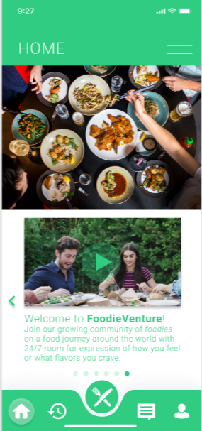 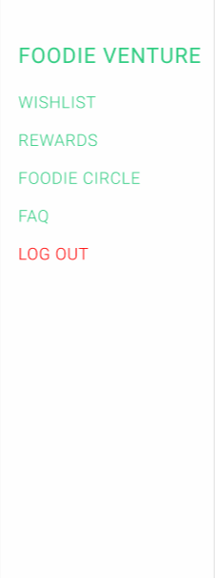

**Figure 2.1 Figure 2.2**

* + - * The participant looked through all the tabs to find the wishlist feature and inevitably found it under the “profile” tab. This was the last tab she looked at.
      * Expressed that it was difficult to know where to look for it.
      * Says that the profile options such as wishlist, rewards and foodie circle could be located on an overlay menu that is accessible no matter what page you’re on in the app. This suggestion is mocked up in **Figure 2.1**, with menu access being indicated by the three lines at the top right corner. **Figure 2.2** shows the overlay menu.
      * Took participant 48 seconds to locate
    - **Observe whether participants understood how to save foods and businesses to their wishlist**
      * The participant was confused because since the heart icon on the food page was already green, it technically meant that the food was already saved. However, it wasn’t; so the participant was confused on whether a green heart means saved or not saved.
    - **Observe participants’ response to Food Generator results**
      * Participant felt that the results were lacking and not exactly what they thought of when they read through the prerecorded answers
      * The participant did say that she is typically a picky eater so she may be biased.
    - **Observe whether participants recognized what each tab and icon meant or represented**
      * Throughout the entire test, the participant seemed unsure of what she could or could not tap. She didn’t always know if an icon was a functionality or not. This is due to our project’s first iteration being very limited in functionality.
      * She was confident in her choice of icon when presented with a task, however.
    - **What surprised you about the app?**
      * “The idea of a rewards page with coupons is pretty nice. I can look at food and eat at the same time”
    - **What did you like about the app?**
      * “There’s not an overwhelming amount of information”
    - **What did you dislike about the app?**
      * “Maybe I’m just not used to operating apps outside of Instagram, Tiktok and Facebook but some things are not where I expected them to be.”
    - **What other tasks did you hope to accomplish, but is not supported by the app?**
      * “Nothing right now. I think you guys just need to add more functionalities to the prototype cause I can barely do anything”
  + **Changes suggested by user test**
    - The major change that the participant recommended was the accessibility of a menu overlay where the wishlist, foodie circle and rewards could be found.
    - Another suggestion made by the participant was to add more color variety. This way, there will be an easier way to indicate what tab a user is on or what icon is activated.

1. **☆ Foodie C. (TIFF’S DAD) ☆**
   * **Was it an informal interview while they used the prototype, or did you give users tasks to do?**

* The usability test was a formal interview as I referenced the test script devised from Lab 5. I assigned the user tasks to do before he spent some time casually exploring the app.
  + **How did you collect data from the interview?**
* Data collection was fulfilled by observing the user’s performance on assigned tasks from Lab 5 through a Zoom call. I gave the participant remote control, enabling the user to carry out tasks in real-time while I ask follow-up questions.
  + - **Observe how long it takes for participants to create an account**
      * ~13 seconds
    - **Record number of errors and time it takes for participants to find wishlist**
      * It was not too hard for the participant to locate the Wishlist button once he arrived at the Profile tab.
      * Agreed that it made sense for users to access their wishlist in their personal profile.
      * However, he suggested it may be slightly more convenient for users if they have access to the Wishlist button no matter which page they are currently on in the app.
      * Took user ~22 seconds to locate its button with barely any assists.
    - **Observe whether participants understood how to save foods and businesses to their wishlist**
      * The position of the heart icon was easy to locate and understand its supported functionality.
    - **Observe participants’ response to Food Generator results**
      * The user felt the general Discover concept was intuitive, but the current results seemed to be incomplete.
      * User liked the convenience in generating another food if he were not interested in the current recommended food.
      * Loved the ability to review a particular food’s history.
    - **Observe whether participants recognized what each tab and icon meant or represented**
      * The user was not entirely sure what the History and News Feed icons represent at first. However, he had a good idea of which icon to interact with when given specific tasks to perform.
    - **What surprised you about the app?**
      * “I love the idea of rewarding users with coupons based on their weekly food intake represented by progress bars. It reminds me of which foods I am missing out throughout the week to maintain a generally healthy, balanced diet.”
    - **What did you like about the app?**
      * “Very creative idea! I like the consistent use of brand colors throughout the app and organized presentation of specific components on each page, such as the food cutout. I felt that the Dine-In and Dine-Out options are great ideas to encourage foodies to actually learn how to cook foods from various cuisines!”
    - **What did you dislike about the app?**
      * “Not anything in particular but the Food Generator results and Rewards achievement progress are a tad confusing. How does it determine a user’s foodie type or whether he/she has actually consumed the food over the week?”
    - **What other tasks did you hope to accomplish, but is not supported by the app?**
      * “I didn’t have anything else to accomplish in mind, but I wished I could interact with more buttons for better navigation during the usability test.”
  + **Changes suggested by user test**
    - Ability to manually enter dishes into a search bar aside from generating a food via completing a quiz — one of our concepts that have yet to be implemented during prototype revision.
    - Inclusion of videos when learning about a food’s cultural origin and reading its description.
    - One important change the user suggested was switching the color opacity of the progress bars on the Rewards page. The current color that supposedly indicates the user’s weekly progress does not resonate well with the corresponding percentage label. The current user’s view is shown in **Figure 3.1**, while his suggestion is mocked up in **Figure 3.2**.

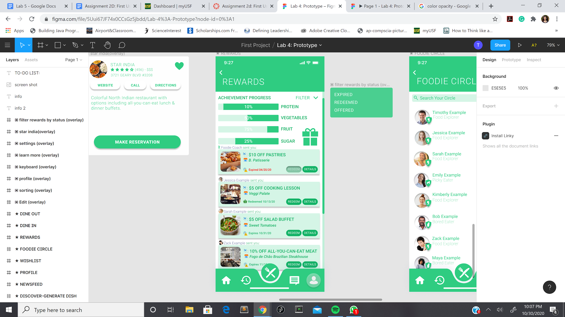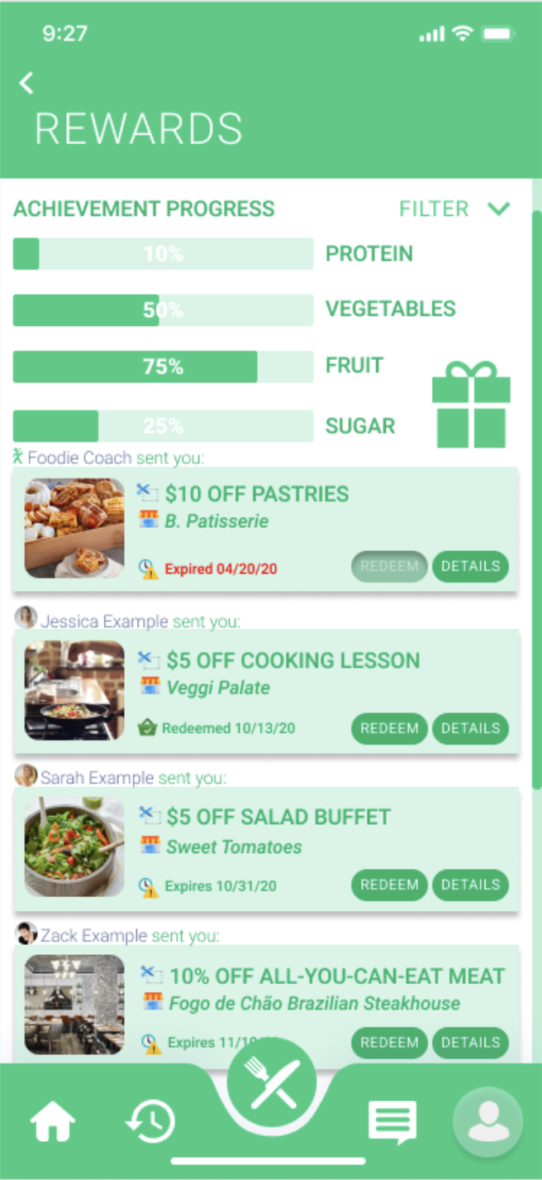

**Figure 3.1 Figure 3.2**

**Conclusion on findings**

Based on our three interviews, we generally found that despite the first iteration of FoodieVenture’s prototype being limited in its functionality, the icons we have to represent specific tabs or functionalities were intuitive to follow. As we synthesized our findings, we see that participants seemed a little stuck at times as a result of feeling like they couldn’t do much with what they had. We recognize that this limitation might have impaired their ability to perform tasks without assists. Tasks that seemed to be difficult or not as easy as the rest of our listed tasks are ones that involved the wishlist. Users seemed to be stuck or doubtful when navigating to and finding the wishlist feature on the app. One suggestion we received was to make the wishlist feature more accessible since the participant imagined it to be something they would utilize often as a user. Overall, we hope to get more features implemented into our prototype so that users will perform tasks efficiently without roadblocks.